T1 Rugby Development Festival  Wednesday 1st October 2025  10:00 – 14:00 | Old Rutlishians Association  The Clubhouse  Poplar Road  London  SW19 3JS

Booking
This is a Development Festival event.
As this is a new event - schools are permitted to enter this event as well as the T1 Rugby Championships for 2025-26 when booking from:
Monday 15th September 2025 at 5pm
For T1 Rugby events, schools may attend with the same participants for 2025/26.
If an event is full, schools will be placed on a waiting list and be notified of this.
MSSP will contact schools should places become available in the build-up to events.

Age Category
Year 5/6

Squad Size
Minimum 7 players. Maximum 10 per squad.
2nd teams available upon request.

Team Eligibility
Mixed gender event
Games will be 7 a-side.
There must be at least 3 girls on the pitch at any time.

Event Eligibility
This is a Development Festival event.
School squads should be well prepared and have time to practise with the NEW competition rules before attending this event.
This event leads into the T1 Rugby Borough Championships competition being delivered for 2025-26.
This development event must be attended to grant qualification for this year’s Borough Championships.

Event Format
The morning will consist of several skill-based games to introduce the new T1 rules. This will lead into the afternoon format of fixtures to practice the skills learned in the morning.
Grass Surface.
Toilets situated inside the clubhouse.
Parking available at ORA ground.

Competition Format
Round-robin groups with at least 3 games. Further fixtures may be added if time permits.

Draw Format /Seedings
School teams will rotate around several tag rugby-based skill stations lead by sports leaders.
Teams will be placed in groups with teams of similar ability for the afternoon set of matches.

Awards
Participation certificates will be presented to all participants.
REFSPECT – certificates

Results
No results will be recorded at this event.
An event report will be available on the webpage under news section after the event.

Winner's Pathway
There is no planned pathway from this event and there may not be an overall winner.

Kit & Equipment
All schools MUST provide their own First Aid kit along with a first aid qualified member of staff.
Please provide own warm up balls. Match balls are provided.
Trainers/Astro moulded and studded boots are allowed. No metal blades will be permitted.
No jewellery permitted. If eyewear is essential, it should be made from plastic rather than glass.
Schools should supply all players with a ‘tag belt’ that has two ribbons (tags) attached to Velcro. The belt must be worn around the waist with all loose clothing tucked in. The tags are positioned either side of the hips.
Schools should wear matching kit/bibs to help team identification during play.

Staffing and Spectators
Staff must complete a team-sheet before on upon arrival.
Spectators will be permitted but must always remain behind touchline barriers and markings.
All staff attending the event must have enhanced DBS clearance and have been fully vetted by their primary school.
Staff will be asked to keep score during the games.

T1 Rugby Borough Championships
RULES - NEW FOR 2025-26
- Ball carriers can run or dodge potential taggers but cannot fend off, guard or shield their tags.
- Players are permitted to spin away from a defender but are NOT permitted to continuously spin.
- Diving in any instance, including scoring a try, is not permitted.
- The game will commence with a Kick, centre field. This kick must travel a distance of at least 10 metres. It must be uncontested by the kicking team to reduce risk of collision.
- Kicking is permitted in the version of the game.
- After a kick, attacking players can move forward, but cannot tag until the receiving player has possession of the ball – or a knock-on has been committed.
- The kick can be from a cone or out of the kicker’s hand to start the play.
- A kick will also restart the game after every try is scored from centre field. The scoring team will kick the ball to the conceding team.
- All other restarts (except a penalty) e.g. change of possession, knock-on, forward pass or ball going out of play will restart with a defensive ‘Tackle Triangle’ and a 'Rip-and-Pass' for the attacking team. The referee will indicate where this restart will commence.
- If a try has not been scored after 7 tags, possession turns over to the defending team at the point of the last tag.
- Any acts of unsporting behaviour will result in a handover to the non-offending team at the place where the incident occurred. Play will restart with a ‘Rip-and-Pass’ with the defensive team forming a Tackle Triangle.
- 2 tags must always be attached for the attacker carrying the ball. If this is not the case, the referee will bring the play back to the previous point of restart with the previous tag count.

Rip-and-Pass: (Attacking Team)
- The ball carrier must return to the spot where the tag occurred.
- Turning to face their own team, the ball carrier presents the ball.
- The nearest support player to ball carrier will come in and rip (take) the ball from this position. This player is called the Dummy Half and must pass the ball sideways or backwards from the Rip and should not run forwards.
- The Dummy Half can take a step laterally to assist with passing. You cannot score as a Dummy Half.
- Any player can be the Dummy Half and the player at Dummy Half could change at every ‘Rip-and-Pass’.
- On a penalty infringement – a ‘Rip-and-Pass’ must be used to restart the game – defenders must retreat 5 metres back.

Tackle Triangle: (Defending Team)
- Before the attacking team can ‘Rip-and-Pass’, a ‘Tackle Triangle’ must be formed by the defending team.
- The tagger will return the tag to the attacker’s belt. At the same time, the 2 closest defenders must from a tackle triangle buy placing their outside hand on the tagger's shoulder - see image attached.
- Once the triangle has been established, the attacking team can rip-and-pass.
- All other defenders must be in line with the base of the triangle. As soon as the attacking Dummy Half passes or kicks the ball, defenders can then move forward.

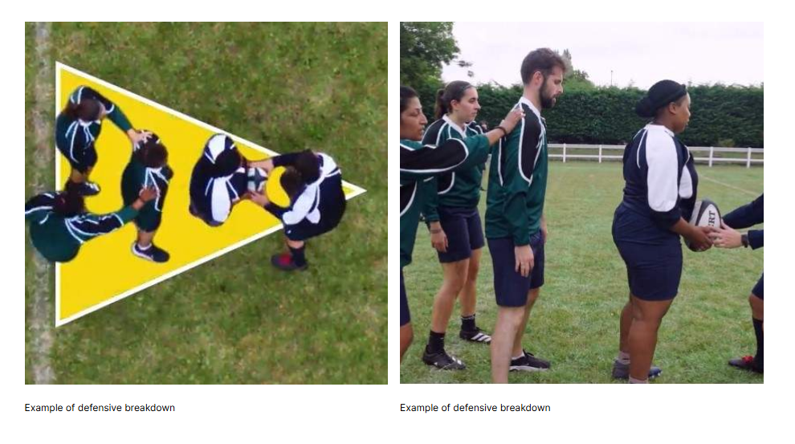

Offside:
Defence...
- If a defender does not retreat to be in line with the base of the tackle-triangle after a tag, they will be deemed to be offside.
- If a tag is made from an offside position, the attacker can pass directly to a team mate to continue the phase but must reattach their tag before joining back in - This tag will not add to the tag count.
- Repeated or deliberate offside offences will be penalised as unsporting behaviour & the tag count reset to zero.
Attack...
- Attacking players cannot receive a pass in front of the ball carrier. This will be deemed to be offside as a forward pass has occurred. This will result in a changeover in possession.
- A player will be offside after a kick IF they collect it without the kicker being in front of them.

Kicking:
- Kicking will be permitted in this version of the game. A kick during open play must be below head height - this will reduce the risk of collisions.
- A kick will be used to start the game (and to restart the game after a try has been scored). This can be from hand with a direct kick, a drop kick or from a cone or tee, centre field. The ball must travel at least 10 metres into the opponent’s half. The kick must be UNCONESTED by the kicking team until gathered by the defenders or the ball has been knocked on.
- If the ball leaves the field via the kick-off, the defending team will receive the ball at point of exit and play will restart with a ‘Rip-and-Pass’ and ‘Tackle Triangle’.
- During play, if a kick is attempted, the ball can be collected by an attacking player coming from an onside position from any distance (10m does not apply).
- A second kick is NOT permitted if it has just been kicked and chased. This will reduce the risk of attackers potentially injuring defenders who are attempting to retrieve the ball. Instead, the ball must be collected by hand, but once the player has control of the ball, they may kick it again.
- The tag count does not reset if a kick and chase has successfully been collected by the kicking team.

Tagging:
- Only the player in possession of the ball can be tagged.
- A ’tag’ is made by a defender removing a tag from the ball carriers’ belt.
- When a defender has removed the tag, he/she stands still at the point at which the tag was removed.
- The ball carrier returns to where the defender is holding the tag and restarts the game by a ‘Rip-and-Pass’ in the correct manner - after a tackle triangle has also been formed by the defenders.
- Immediately before a ‘Rip-and-Pass’, the tagger must re-attach the tag that has been taken, back onto their belt. This prevents any disadvantage in the play.
- Players cannot take part in the game without both tags properly in place on their belt - one tag positioned on each hip - not in front or behind.

Scoring a Try:
- A try is scored by placing or touching the ball down on or over your opponents' try line.
- If tagged in the act of scoring the try will stand. The attacker is permitted 1 step / 1 metre after being tagged to place the ball down.
- After a try has been scored the scoring team will restart with a kick, centre field on the halfway line, into the non-scoring teams' half.
- All other starts and restarts will be with a ‘Rip-and-Pass’ whatever the situation.

For more information on the rules of T1 Tag Rugby, please visit: https://rise.articulate.com/share/59reAYjLlRkRT5zPFn0RijXFYUfelTa3#/

For Tag Rugby based skilled games through School Games, please visit:
https://media.yourschoolgames.com/documents/sport-format-resources/Rugby_Union_Primary_Format.pdf

First Aid
MSSP will have a basic first aid kit and qualified person at all events but will not be available to tend to less urgent first aid, as they will be delivering the event. As part of the school’s risk assessment a qualified first aider should always be with the school team (including travel) to tend to their children during the event.

Team-sheets
To help us support our Equality, Diversity and Inclusion aims, all school teams must complete and submit the attached MSSP Event Entry - EDI Team sheet to register for this event. We do not require the children's names, just initials or first names are fine. This data is vital to help us improve equity and access for all. We want all Merton students to be able to represent their schools in activities they enjoy and, in an environment, where they feel a sense of belonging. The data you provide us will help us to review and improve our offer as we strive to achieve this.

Risk Assessments
Please see the Risk Assessment in the 'Resources' section on the event webpage for event specific planning and considerations.
mertonssp.org.uk/competitions

REFSPECT
MSSP values the contributions by all those involved in making our events a FUN, safe and enjoyable environment for children to take part in sport. To ensure our events continue to be successful we promote our REFSPECT campaign. We expect everyone attending our events to maintain respect for the rules, officials, opponents, teammates and themselves. Only designated staff and volunteers will be allowed on the side-lines. All spectators are to remain behind the barriers, providing positive support and encouraging a fun and fair event.
If any staff, adults or children are deemed to be in breach of our REFSPECT codes of conduct they will be asked to leave the event, and the Head Teacher of the relevant school will be informed immediately.

For more information about REFSPECT and codes of conduct for attendance at our events, please click here
mertonssp.org.uk/refspect

Photo Consent
Photographs will be taken at this event by staff members from MSSP and may be used for promotional material. If you have any children that do not have permission to be photographed, please inform a member of staff before the start of the event.
Please ensure your school only take photographs of their own students and do not share any photos of other children on social media without consent from that school.

Social Media
For information and updates from our events, please follow and use the platforms below:

Email: info@mertonssp.org.uk

X: x.com/MertonSSP

Instagram: instagram.com/mertonssp

MSSP Duty of Care
MSSP have a duty to take all measures that are reasonable in the circumstances to ensure the health, safety, wellbeing and welfare of all participants and any other attendees involved in the relevant event. MSSP have tried to ensure that all reasonable steps have been taken in its duty of care being discharged, and to the requisite standard of care, MSSP have ensured the following guidance and actions have been adhered to and carried out:
That the advice of the UK Government and public health authorities has been followed
That the bespoke guidance and protocols issued by the relevant NGB, federation and/or umbrella organisation (if applicable) have been followed.

Safeguarding and DBS
MSSP acknowledges the duty of care to safeguard and promote the welfare of children and is committed to ensuring safeguarding practice reflects statutory responsibilities, government guidance and complies with best practice and the requirements of the Partnership’s host organisation, the Harris Federation.

We recognise that the welfare and interests of children are paramount in all circumstances. We aim to ensure that regardless of age, ability or disability, gender reassignment, race, religion or belief, sex or sexual orientation, socio-economic background, all children and young leaders:
have a positive and enjoyable experience of sport or physical activity at MSSP events in a safe and child centred environment are protected from abuse whilst participating or officiating at MSSP events.

All MSSP staff at the event are fully vetted and enhanced DBS checked. It is the schools’ responsibility to ensure any staff and volunteers who attend the event comply with the host venue safeguarding and welfare policy and can provide documentation to support this on request.

If you have any concerns about a child at our event, please make sure you say something. The MSSP safeguarding team contact details will be on display at all events or for more information on who to speak to please click here
mertonssp.org.uk/contact

Comments, Compliments and Complaints
MSSP aims to deliver a first-class service to all its stakeholders. We see all feedback, whether good or bad, as a valuable way for us to learn and improve. Therefore, we welcome all comments, compliments and complaints. For further details, please click here
mertonssp.org.uk/comments-compliments-and-complaints

