Cross Country Borough Championships  Friday 3rd October 2025  12:30 – 14:30 | Abbey Recreation Ground  South Wimbledon  Parking on Nursery Road entrance: 25 Nursery Rd, Merton, London SW19 3BT

Booking
- This event is open to all schools to sign up to on the initial booking date of:
- Monday 15th September 2025 at 5pm

Age Category
- Year 4-6

Squad Size
- 5 Boys and 5 Girls per year group.

Eligibility
- This is a Borough Championships event.
- Only Year 4, 5 and 6 pupils. (Year 6 will race first)
- There will be a boys’ race and girls’ race per year group.
- Teams to be made up of five girls and five boys in each year group (e.g. five Year 6 girls + five Year 6 boys)
- Schools are encouraged to select their strongest squad and should be well prepared with the competition rules and distances before attending this event.

Event Details
- Parking is available via Nursery Road entrance
- Toilets will be accessible near the entrance to Abbey Rec Ground near the main entrance to park
- Access closed to members of the public after 12.30pm.

Competition Format
- Athletes will race in their own year group.
- Girls and boys will race separately.
- Year 6 Races – placings cards from 1–50 will be distributed to runners as they finish. School coaches are to collect and record these placings on the team result sheet and hand back to event organisers to be collated for the overall team result.

Draw Format
Runners will race just one race in the race order as follows:
- Year 6 Girls
- Year 6 Boys
- Year 5 Girls
- Year 5 Boys
- Year 4 Girls
- Year 4 Boys

Rules
- Children will aim to complete two laps of the large running course (approx. total distance = 1600m).
- Children must make their way to the start line once they have been called by the starter marshal.
- The start clacker will be used to start races.
- Once the race begins, runners must keep the course flags and cones to their right-hand side, ensuring they stay on the running course throughout the race.
- Teachers and coaches are not permitted to run alongside the runners.
- First aiders may attend children by crossing the track with the support of an MSSP steward.

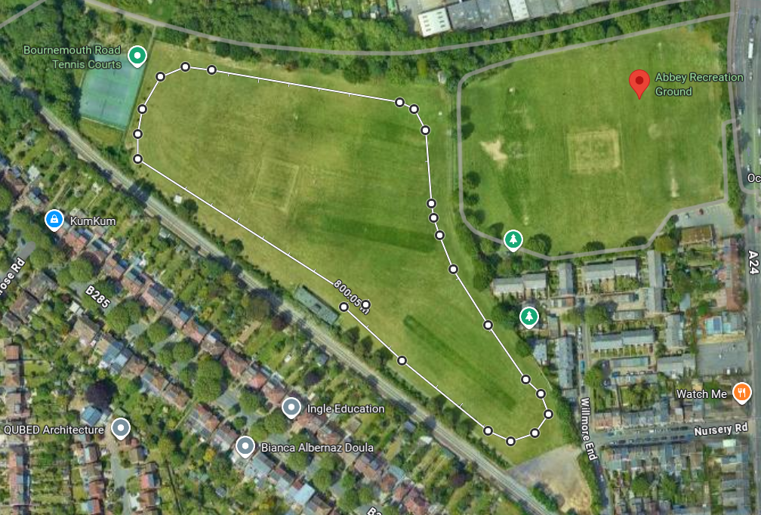

Awards
- Winners: GOLD medal and certificates.
- Year 6 Team Award. Boys trophy. Girls Trophy.
- Individual Runners-Up: SILVER medal and certificates.
- Individual 3rd Place: BRONZE medal and certificates.
- 4th – 10th Place: Placing certificates.
- Participation certificates will be presented to all participants.

Results
- Results and event report will be available on the news webpage within 24 hours of the event ending.

Winner’s Pathway
- There is no planned pathway from this event.

Kit & Equipment
- All schools MUST provide their own First Aid kit along with a first aid qualified member of staff.
- No jewellery permitted. If eyewear is essential, it should be made from plastic rather than glass.
- Runners of the same school should wear the same colour tops/bibs.
- No jewellery permitted.
- All children must wear appropriate footwear. For the secondary school event only, there will be one small section of carpeted terrain to cover a concrete path running alongside the course. Please consider this when choosing footwear.

Staffing and Spectators

- The Nursery Road site is not a public site - it is hosted by Harris Academy Wimbledon and cannot be accessed by members of the public.
- For safety reasons we cannot leave the middle entrance gate open during the event. It will remain locked once all schools have arrived therefore it would be beneficial for children to use the toilets upon arrival on the way to the registration area.

We want to facilitate the opportunity for parents to watch the races so, if you wish for your parents to spectate...

- They need to arrive with the school team from 12.15 - 12:30 for registration to gain access.
- They will not be permitted general entry to Nursery Field once the races have begun and would have to watch from Abbey Recreation fencing area.
- PE Co's must give a printed list to MSSP of any parents wanting to arrive later. (We must treat this venue as a school site to support the safety of the children and young sports leaders.) You will be responsible for meeting them at the gate between races to escort them to the SPECTATOR ZONE.
- Spectators must remain with their corresponding school in the Spectator Zone and are NOT PERMITTED to run alongside the racers.
- You will be responsible for behaviour standards of all pupils and visiting parents from your school.
- Please remind them in advance of the event of our REFSPECT Code of Conduct
- Staff must wear a yellow identification sash throughout. This will be provided upon registration.
- You are responsible for the whereabouts of your children at all times.
- Children must always remain with you the Spectator Zone unless racing.
- Please support us in getting your pupils to the start line for each race in time.
- First Aid - children should not be left alone in the spectator zone, so if a child from your school needs immediate assistance, please allocate a second member of staff to be responsible to attend the incident - around the course or first aid tent area, and one to remain with the rest of the team. MSSP staff will be nearby to support.

Staff must complete a team-sheet for their participants before or upon arrival.

First Aid
MSSP will have a basic first aid kit and qualified person at all events but will not be available to tend to less urgent first aid, as they will be delivering the event. As part of the school’s risk assessment a qualified first aider should always be with the school team (including travel) to tend to their children during the event.

Team-sheets
To help us support our Equality, Diversity and Inclusion aims, all school teams must complete and submit the attached MSSP Event Entry - EDI Team sheet to register for this event. We do not require the children's names, just initials or first names are fine. This data is vital to help us improve equity and access for all. We want all Merton students to be able to represent their schools in activities they enjoy and, in an environment, where they feel a sense of belonging. The data you provide us will help us to review and improve our offer as we strive to achieve this.

Risk Assessments
Please see the Risk Assessment in the 'Resources' section on the event webpage for event specific planning and considerations.
mertonssp.org.uk/competitions

REFSPECT
MSSP values the contributions by all those involved in making our events a FUN, safe and enjoyable environment for children to take part in sport. To ensure our events continue to be successful we promote our REFSPECT campaign. We expect everyone attending our events to maintain respect for the rules, officials, opponents, teammates and themselves. Only designated staff and volunteers will be allowed on the side-lines. All spectators are to remain behind the barriers, providing positive support and encouraging a fun and fair event.
If any staff, adults or children are deemed to be in breach of our REFSPECT codes of conduct they will be asked to leave the event, and the Head Teacher of the relevant school will be informed immediately.

For more information about REFSPECT and codes of conduct for attendance at our events, please click here
mertonssp.org.uk/refspect

Photo Consent
Photographs will be taken at this event by staff members from MSSP and may be used for promotional material. If you have any children that do not have permission to be photographed, please inform a member of staff before the start of the event.
Please ensure your school only take photographs of their own students and do not share any photos of other children on social media without consent from that school.

Social Media
For information and updates from our events, please follow and use the platforms below:

Email: info@mertonssp.org.uk

X: x.com/MertonSSP

Instagram: instagram.com/mertonssp

MSSP Duty of Care
MSSP have a duty to take all measures that are reasonable in the circumstances to ensure the health, safety, wellbeing and welfare of all participants and any other attendees involved in the relevant event. MSSP have tried to ensure that all reasonable steps have been taken in its duty of care being discharged, and to the requisite standard of care, MSSP have ensured the following guidance and actions have been adhered to and carried out:
That the advice of the UK Government and public health authorities has been followed
That the bespoke guidance and protocols issued by the relevant NGB, federation and/or umbrella organisation (if applicable) have been followed.

Safeguarding and DBS
MSSP acknowledges the duty of care to safeguard and promote the welfare of children and is committed to ensuring safeguarding practice reflects statutory responsibilities, government guidance and complies with best practice and the requirements of the Partnership’s host organisation, the Harris Federation.

We recognise that the welfare and interests of children are paramount in all circumstances. We aim to ensure that regardless of age, ability or disability, gender reassignment, race, religion or belief, sex or sexual orientation, socio-economic background, all children and young leaders:
have a positive and enjoyable experience of sport or physical activity at MSSP events in a safe and child centred environment are protected from abuse whilst participating or officiating at MSSP events.

All MSSP staff at the event are fully vetted and enhanced DBS checked. It is the schools’ responsibility to ensure any staff and volunteers who attend the event comply with the host venue safeguarding and welfare policy and can provide documentation to support this on request.

If you have any concerns about a child at our event, please make sure you say something. The MSSP safeguarding team contact details will be on display at all events or for more information on who to speak to please click here
mertonssp.org.uk/contact

Comments, Compliments and Complaints
MSSP aims to deliver a first-class service to all its stakeholders. We see all feedback, whether good or bad, as a valuable way for us to learn and improve. Therefore, we welcome all comments, compliments and complaints. For further details, please click here
mertonssp.org.uk/comments-compliments-and-complaints

