Cross Country Borough Championships  Friday 3rd October 2025  14:30 – 16:30 | Abbey Recreation Ground  South Wimbledon

Booking
- This event is open to all Merton SECONDARY schools

Age Category
- Year 7-13

Squad Size
- 15 participants permitted per race group.

Eligibility
- This is a Borough Championships event.
- There will be a boys’ race and girls’ race per year group.
- Race categories may be combined depending on entrant numbers.
- Schools are encouraged to select their strongest squad and should be well prepared with the competition rules and distances before attending this event.

Event Details
- Mini-bus parking is NOT NOW available via Nursery Road entrance. Please use Abbey Rec.
- Toilets will be accessible near the entrance to Abbey Rec Ground near the main entrance to park
- Upon arrival, please head to the purple gazebo in Nursery Rec to register.
- Nursery car park entrance will be out of action for 2025.
- Abbey Rec is open to the public - Nursery Field is not. Please help us to be vigilant of any member of the public with access to Nursery via the middle gate. This is technically a school sports site during this time, and we are not permitted to allow non-school related visitors any access.
- Toilets are located near the entrance to Abbey Rec.
- Between parks there is a narrow path of tarmac. This will be covered with a layer of carpet material, secured down, to reduce risk of slips, but please advise athletes to approach cautiously per lap.

Competition Format
- Yr 7 and 8/9 Athletes will complete 2 laps of the below course, covering both fields.
- Yr 10/11 and 12/13 Athletes will complete 2 laps and an additional lap of Nursery Rec only.
- The first race is scheduled to start at 16.15. You can select a maximum of 15 athletes per race and gender. Races may be combined dependant on entry numbers.

- Race 1 – Year 7 Girls (2.5k)
- Race 2 – Year 7 Boys (2.5k)
- Race 3 – Year 8/9 Girls (2.5k)
- Race 4 - Year 8/9 Boys (2.5k)
- Race 5 – Year 10/11 Boys and Girls (3.6k)
- Race 6 – Year 12/13 Boys and Girls (3.6k)

- Schools must send appropriate supervision in line with their schools’ policy on pupils attending trips/events.
- The event will be outdoors and there will be no indoor areas available in case of bad weather so please ensure your athletes come prepared with warm, waterproof clothing.

Rules
- Participants must make their way to the start line once they have been called by the starter marshal.
- The start clacker will be used to start races.
- Once the race begins, runners must keep the course flags and cones to their right-hand side, ensuring they stay on the running course throughout the race.
- Teachers and coaches are not permitted to run alongside the runners.
- First aiders may attend children by crossing the track with the support of an MSSP steward.

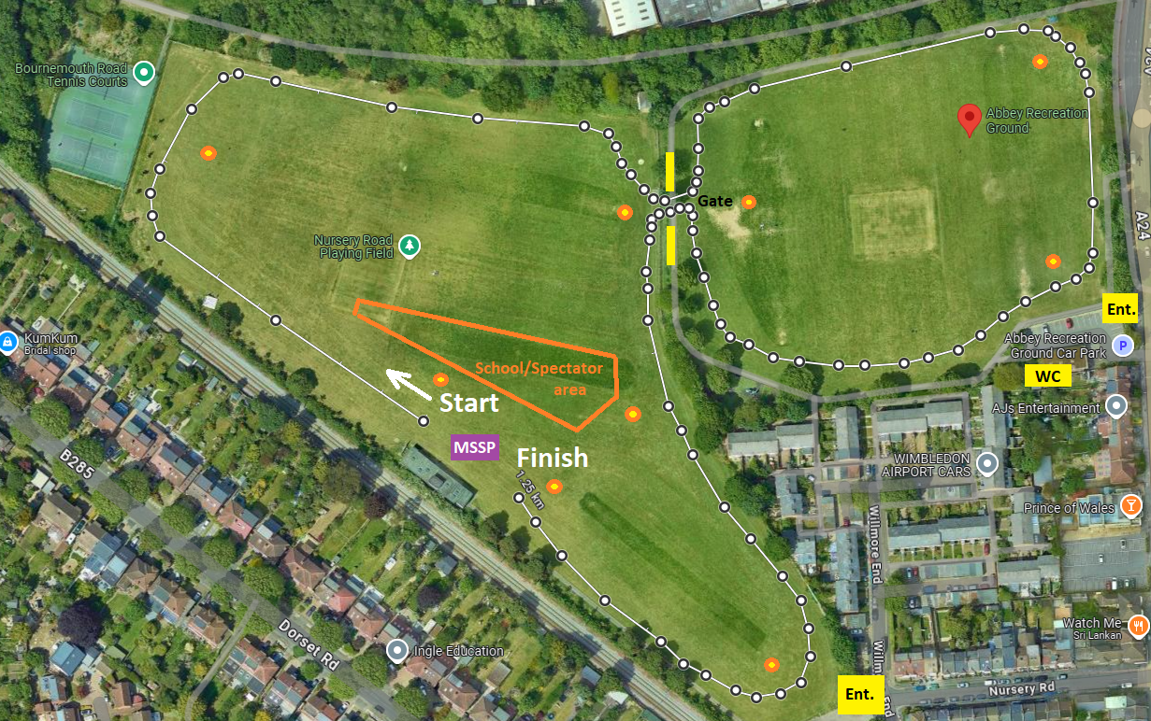

Awards
- Winners: GOLD medal and certificates.
- Individual Runners-Up: SILVER medal and certificates.
- Individual 3rd Place: BRONZE medal and certificates.
- 4th – 10th Place: Placing certificates.
- Participation certificates will be presented to all participants.

Results
- Results and event report will be available on the news webpage within 24 hours of the event ending.

Winner’s Pathway
- Surrey County Cross Country Championships (held at Reigate Park in January 2026)
- Timings will be recorded for the top 10 athletes per race. These will be measured against minimum entry requirements and qualifying athletes will be invited to represent Team Merton at the SSAA event.

Kit & Equipment
- All schools MUST provide their own First Aid kit along with a first aid qualified member of staff.
- No jewellery permitted. If eyewear is essential, it should be made from plastic rather than glass.
- Runners of the same school should wear the same colour tops/bibs.
- No jewellery permitted.
- All children must wear appropriate footwear. For the secondary school event only, there will be one small section of carpeted terrain to cover a concrete path running alongside the course. Please consider this when choosing footwear.
Staffing and Spectators

- The Nursery Road site is not a public site - it is hosted by Harris Academy Wimbledon and should not be accessed by members of the public.
- Parent spectators are permitted but at each schools' responsibility and ideally should arrive at the same time as the school upon registering. If they are coming late, please meet them at the gate and ask them to remain in the spectator area near the start finish.
- Spectators must remain with their corresponding school in the Spectator Zone and are NOT PERMITTED to run alongside the racers.
- You will be responsible for behaviour standards of all pupils and visiting parents from your school.
- Please remind them in advance of the event of our REFSPECT Code of Conduct
- Staff must wear a yellow identification sash throughout. This will be provided upon registration.
- You are responsible for the whereabouts of your children at all times.
- Children must always remain with you the Spectator Zone unless racing.
- Please support us in getting your pupils to the start line for each race in time.
- First Aid - children should not be left alone in the spectator zone, so if a child from your school needs immediate assistance, please allocate a second member of staff to be responsible to attend the incident - around the course or first aid tent area, and one to remain with the rest of the team. MSSP staff will be nearby to support.

Staff must complete a team-sheet for their participants before or upon arrival.

First Aid
MSSP will have a basic first aid kit and qualified person at all events but will not be available to tend to less urgent first aid, as they will be delivering the event. As part of the school’s risk assessment a qualified first aider should always be with the school team (including travel) to tend to their children during the event.

Team-sheets
To help us support our Equality, Diversity and Inclusion aims, all school teams must complete and submit the attached MSSP Event Entry - EDI Team sheet to register for this event. We do not require the children's names, just initials or first names are fine. This data is vital to help us improve equity and access for all. We want all Merton students to be able to represent their schools in activities they enjoy and, in an environment, where they feel a sense of belonging. The data you provide us will help us to review and improve our offer as we strive to achieve this.

Risk Assessments
Please see the Risk Assessment in the 'Resources' section on the event webpage for event specific planning and considerations.
mertonssp.org.uk/competitions

REFSPECT
MSSP values the contributions by all those involved in making our events a FUN, safe and enjoyable environment for children to take part in sport. To ensure our events continue to be successful we promote our REFSPECT campaign. We expect everyone attending our events to maintain respect for the rules, officials, opponents, teammates and themselves. Only designated staff and volunteers will be allowed on the side-lines. All spectators are to remain behind the barriers, providing positive support and encouraging a fun and fair event.
If any staff, adults or children are deemed to be in breach of our REFSPECT codes of conduct they will be asked to leave the event, and the Head Teacher of the relevant school will be informed immediately.

For more information about REFSPECT and codes of conduct for attendance at our events, please click here
mertonssp.org.uk/refspect

Photo Consent
Photographs will be taken at this event by staff members from MSSP and may be used for promotional material. If you have any children that do not have permission to be photographed, please inform a member of staff before the start of the event.
Please ensure your school only take photographs of their own students and do not share any photos of other children on social media without consent from that school.

Social Media
For information and updates from our events, please follow and use the platforms below:

Email: info@mertonssp.org.uk

X: x.com/MertonSSP

Instagram: instagram.com/mertonssp

MSSP Duty of Care
MSSP have a duty to take all measures that are reasonable in the circumstances to ensure the health, safety, wellbeing and welfare of all participants and any other attendees involved in the relevant event. MSSP have tried to ensure that all reasonable steps have been taken in its duty of care being discharged, and to the requisite standard of care, MSSP have ensured the following guidance and actions have been adhered to and carried out:
That the advice of the UK Government and public health authorities has been followed
That the bespoke guidance and protocols issued by the relevant NGB, federation and/or umbrella organisation (if applicable) have been followed.

Safeguarding and DBS
MSSP acknowledges the duty of care to safeguard and promote the welfare of children and is committed to ensuring safeguarding practice reflects statutory responsibilities, government guidance and complies with best practice and the requirements of the Partnership’s host organisation, the Harris Federation.

We recognise that the welfare and interests of children are paramount in all circumstances. We aim to ensure that regardless of age, ability or disability, gender reassignment, race, religion or belief, sex or sexual orientation, socio-economic background, all children and young leaders:
have a positive and enjoyable experience of sport or physical activity at MSSP events in a safe and child centred environment are protected from abuse whilst participating or officiating at MSSP events.

All MSSP staff at the event are fully vetted and enhanced DBS checked. It is the schools’ responsibility to ensure any staff and volunteers who attend the event comply with the host venue safeguarding and welfare policy and can provide documentation to support this on request.

If you have any concerns about a child at our event, please make sure you say something. The MSSP safeguarding team contact details will be on display at all events or for more information on who to speak to please click here
mertonssp.org.uk/contact

Comments, Compliments and Complaints
MSSP aims to deliver a first-class service to all its stakeholders. We see all feedback, whether good or bad, as a valuable way for us to learn and improve. Therefore, we welcome all comments, compliments and complaints. For further details, please click here
mertonssp.org.uk/comments-compliments-and-complaints

Dear PE Leads,

Please find below information ahead of the Secondary Schools Cross Country Trials.

Please confirm your school attendance on the day as well as number of staff able to attend. Event Support Roles will be shared out between staff once confirmed.

Attending teams are required to complete and return the team-sheet attached. Thank you.

The races are structured to provide a pathway to the Surrey Schools Athletics Association Inter District Cross Country Championships where pupils with the top qualifying times (once compared with regional times) will be given the opportunity to represent Merton. Details of this event have not been confirmed but we will be taking placings and times regardless.

Event: Secondary Schools Cross Country Trials
Date: Friday 3rd October 2025
Time: 3.45pm-5.45pm arrive no later than 4pm for registration (please let us know if this will be difficult)
Venue: Abbey Recreation Ground (Nursery Road entrance)
Nursery Road Car Park is located next to 25 Nursery Rd, Merton, London SW19 3BT
Toilets will be available in the changing rooms near the Abbey Rec main road entrance

The first race is scheduled to start at 16.15pm. You can select a maximum of 15 athletes per race and gender. Races may be combined dependant on entry numbers.

Race 1 – Year 7 Girls (2.5k)
Race 2 – Year 7 Boys (2.5k)
Race 3 – Year 8/9 Girls (2.5k)
Race 4 - Year 8/9 Boys (2.5k)
Race 5 – Year 10/11 Boys and Girls (3.6k)
Race 6 – Year 12/13 Boys and Girls (3.6k)

Schools must send appropriate supervision in line with their schools policy on pupils attending trips/events.
The event will be outdoors and there will be no indoor areas available in case of bad weather so please ensure your athletes come prepared with warm, waterproof clothing.

Equality, Diversity and Inclusion Monitoring | 2024/25
In order for Merton SSP to be able to further our understanding of the effectiveness and accessibility of our sports programmes, we have designed an MSSP Team Entry - Event EDI Registration Team-sheet with the intention of collecting data to provide a detailed record of who is attending our sports events across the year. In advance of arrival to our events, school team leaders will be required to complete this team-sheet to register for the event. This will support the partnership to gain a wider understanding of EDI through the sporting opportunities on offer to schools across our Merton Borough.

For the pupils attending on the day, please have ready the following:
Age group | Boys/Girls ratio | Ethnicity | SEND participants | PP Pupils | Photo consent per child

REFSPECT
I would urge you to make anybody who intends to attend the competition aware of our REFSPECT campaign. By providing a safe, fun, and positive environment for children to participate in sports it will make it a much more enjoyable experience for everyone involved. This will be highlighted by our REFSPECT award, which you can find details via https://mertonssp.org.uk/refspect/ and staff will be given further information about this at the event.

Thank you
Merton SSP

