Open Dodgeball Festival KS2  Friday 24th October 2025  12:30 – 14:30 | AELTC Community Tennis Centre  170 Grand Drive  London  SW20 9NB

Booking

Please confirm in the comments box upon sign-up if you aim to bring a:
- Yr 3/4 team
- Yr 5/6 team
- 1 of each (or more)

This is an Open Festival event.
Schools may enter on the initial booking date of:
Monday 15th September 2025 at 5pm
If an event is full, schools will be placed on a waiting list and be notified of this.
MSSP will contact schools should places become available in the build-up to events.

Age Category
Year 3/4 OR Year 5/6

Squad Size
Maximum of 8 players in a squad.
6 players on the pitch at any time.

Eligibility
Mixed gender event – no gender requirements.
(There is a Girls only Dodgeball event if this is preferred.)

The intent and principles of the festival have been designed to support pupils learning of the different activities and not be restricted by enforcement of the rules.
The festival is primarily focused on fun, participation and skill development.
We anticipate that many children may not have attended one of our sports events before and aim for children to learn more about the sports and skills throughout the day.

Kit & Equipment
All schools MUST provide their own First Aid kit along with a first aid qualified member of staff.
This event will be played on hardcourt surface. Trainers are permitted. No studs required.
Players of the same team should wear the same colour tops/bibs.
No jewellery, baseball caps etc.
It is advised that if eyewear is essential, it should be made from plastic rather than glass.

Event/Draw Format
This is a festival event. No scores will be recorded or placings awarded.
The event will take place on hardcourt surface.
Number of fixtures will be dependent on entries.
Round robin groups. Teams will play against as many other teams in their group as time permits on the day.

Staffing and Spectators
Spectators will not be permitted entry to any school/private sports facilities.
Primary schools must inform parents in advance when inviting students to take part.
All staff attending the event must have enhanced DBS clearance and have been fully vetted by

Awards
REFSPECT winners - Certificates
Participation certificates will be presented to all participants.
This is a non-medal event.

Results
Results and event report will be available on the news webpage within 24 hours of the event ending.

Winner’s Pathway
There is no planned pathway from this event.

Open Dodgeball Festival

Rules
- Teams must try and get all opposition players out by hitting them under waist height by throwing a dodgeball.
- Usual game length is 4 rounds of 2 minute quarters.
- If a team gets all of the opposite out before the end of the time, teams will wait and reset for the next quarter.
- Play will start with a set of balls laid out in the middle of the court and players’ with one foot on the back line. Play begins when whistle is blown. Players must exit the ‘safe zone’ before they can throw the ball at the opposition. Any balls thrown in the initial ‘safe zone’ will not count.
- If the ball hits a player under waist height, before bouncing first, they must walk off court and wait in the ‘out zone’.
- If a player catches a ball without it bouncing, the player who threw the ball is out. The team who caught the ball then get back ALL players who had previously been waiting in the ‘out zone’.
- Players cannot exit the court lines during the match, unless to retrieve a stray ball.
- Players who are out must wait in the ‘out zone’.
- Balls cannot be kicked.
- Any players showing foul play will be taken off court and disqualified for that match.
- Foul play consists of: purposely aiming at the opposition above waist height, not going out when hit below waist height, dissent towards any player or official.

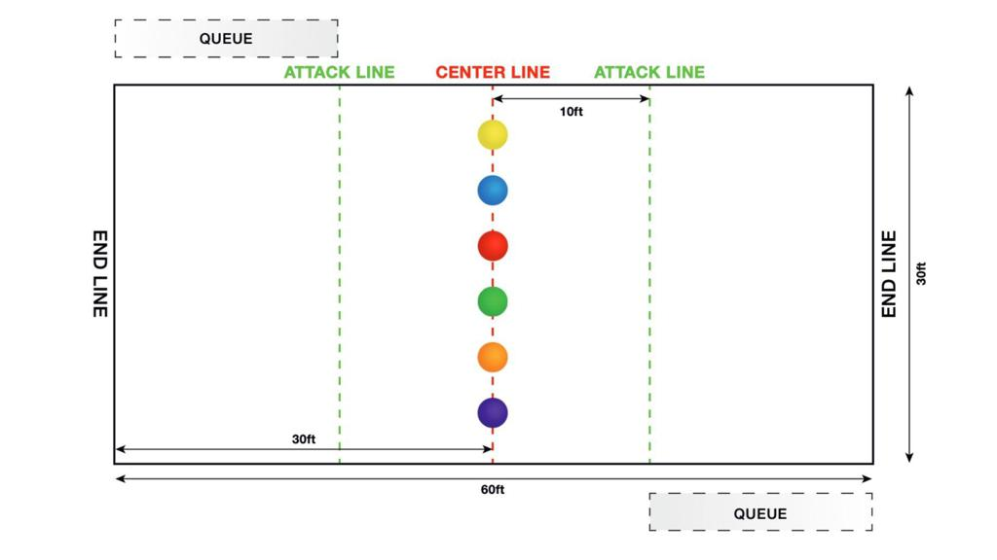

First Aid
MSSP will have a basic first aid kit and qualified person at all events but will not be available to tend to less urgent first aid, as they will be delivering the event. As part of the school’s risk assessment a qualified first aider should always be with the school team (including travel) to tend to their children during the event.

Team-sheets
To help us support our Equality, Diversity and Inclusion aims, all school teams must complete and submit the attached MSSP Event Entry - EDI Team sheet to register for this event. We do not require the children's names, just initials or first names are fine. This data is vital to help us improve equity and access for all. We want all Merton students to be able to represent their schools in activities they enjoy and, in an environment, where they feel a sense of belonging. The data you provide us will help us to review and improve our offer as we strive to achieve this.

Risk Assessments
Please see the Risk Assessment in the 'Resources' section on the event webpage for event specific planning and considerations.
mertonssp.org.uk/competitions

REFSPECT
MSSP values the contributions by all those involved in making our events a FUN, safe and enjoyable environment for children to take part in sport. To ensure our events continue to be successful we promote our REFSPECT campaign. We expect everyone attending our events to maintain respect for the rules, officials, opponents, teammates and themselves. Only designated staff and volunteers will be allowed on the side-lines. All spectators are to remain behind the barriers, providing positive support and encouraging a fun and fair event.
If any staff, adults or children are deemed to be in breach of our REFSPECT codes of conduct they will be asked to leave the event, and the Head Teacher of the relevant school will be informed immediately.

For more information about REFSPECT and codes of conduct for attendance at our events, please click here
mertonssp.org.uk/refspect

Photo Consent
Photographs will be taken at this event by staff members from MSSP and may be used for promotional material. If you have any children that do not have permission to be photographed, please inform a member of staff before the start of the event.
Please ensure your school only take photographs of their own students and do not share any photos of other children on social media without consent from that school.

Social Media
For information and updates from our events, please follow and use the platforms below:

Email: info@mertonssp.org.uk

X: x.com/MertonSSP

Instagram: instagram.com/mertonssp

MSSP Duty of Care
MSSP have a duty to take all measures that are reasonable in the circumstances to ensure the health, safety, wellbeing and welfare of all participants and any other attendees involved in the relevant event. MSSP have tried to ensure that all reasonable steps have been taken in its duty of care being discharged, and to the requisite standard of care, MSSP have ensured the following guidance and actions have been adhered to and carried out:
That the advice of the UK Government and public health authorities has been followed
That the bespoke guidance and protocols issued by the relevant NGB, federation and/or umbrella organisation (if applicable) have been followed.

Safeguarding and DBS
MSSP acknowledges the duty of care to safeguard and promote the welfare of children and is committed to ensuring safeguarding practice reflects statutory responsibilities, government guidance and complies with best practice and the requirements of the Partnership’s host organisation, the Harris Federation.

We recognise that the welfare and interests of children are paramount in all circumstances. We aim to ensure that regardless of age, ability or disability, gender reassignment, race, religion or belief, sex or sexual orientation, socio-economic background, all children and young leaders:
have a positive and enjoyable experience of sport or physical activity at MSSP events in a safe and child centred environment are protected from abuse whilst participating or officiating at MSSP events.

All MSSP staff at the event are fully vetted and enhanced DBS checked. It is the schools’ responsibility to ensure any staff and volunteers who attend the event comply with the host venue safeguarding and welfare policy and can provide documentation to support this on request.

If you have any concerns about a child at our event, please make sure you say something. The MSSP safeguarding team contact details will be on display at all events or for more information on who to speak to please click here
mertonssp.org.uk/contact

Comments, Compliments and Complaints
MSSP aims to deliver a first-class service to all its stakeholders. We see all feedback, whether good or bad, as a valuable way for us to learn and improve. Therefore, we welcome all comments, compliments and complaints. For further details, please click here
mertonssp.org.uk/comments-compliments-and-complaints

