Inclusive Cross Country Course Festival  Wednesday 24th September 2025  12:30 – 14:00 | Abbey Recreation Ground  South Wimbledon  Parking on Nursery Road entrance: 25 Nursery Rd, Merton, London SW19 3BT

Booking
This is an Inclusive Festival event.
Schools may enter on the initial booking date of:
Monday 15th September 2025 at 5pm
If an event is full, schools will be placed on a waiting list and be notified of this.
MSSP will contact schools should places become available in the build-up to events.

Age Category
Year 3-6 and Year 7

Squad Size
Approx. 10 per year group. Please indicate number of participants upon registration.

Eligibility
Mixed gender event
Pupils with SEND should be prioritised by schools when selecting a squad

Event Format
This is an Inclusive Festival event with an emphasis on fun, participation and getting active.
This event will be on a grass surface. The terrain may be more challenging for participants with physical needs.
Parking is available via Nursery Road entrance
Toilets will be accessible near the entrance to Abbey Recreation Ground near the main entrance to park.

Competition Format
There are no timings or race results recorded, and children can take part at their own pace.

Draw Format /Seedings
There will be no draws

Awards
Participation certificates will be presented to all participants.

Results
No results will be recorded at this event.
An event report will be available on the webpage under news section after the event.

Winner's Pathway
There is no planned pathway from this event and there may not be an overall winner.

Kit & Equipment
All schools MUST provide their own First Aid kit along with a first aid qualified member of staff.
Please provide own warm up balls. Match balls are provided.
Trainers/Astro moulded and studded boots are allowed. No metal blades will be permitted.
No jewellery permitted. If eyewear is essential, it should be made from plastic rather than glass.

Staffing and Spectators
Staff must complete a team-sheet before on upon arrival.
Spectators are not permitted as on school site access to field.
All staff attending the event must have enhanced DBS clearance and have been fully vetted by their primary school. DBS numbers will be required in advance for events on school sites.

Inclusive Cross Country Course Festival

Rules
Children will aim to complete one lap of the running course – clockwise (map attached)
Course distance approx. 800m including several fun challenge obstacles along the way.

Children must make their way to the designated start line once they have been called by the starter marshal.
Once the race begins, runners must keep the course flags and cones to their right-hand side, ensuring they stay on the running course throughout the race.
If a teacher or coach needs to assist a child around the course, they must clarify this with MSSP before the start of the race and take a yellow sash to identify them as race support.

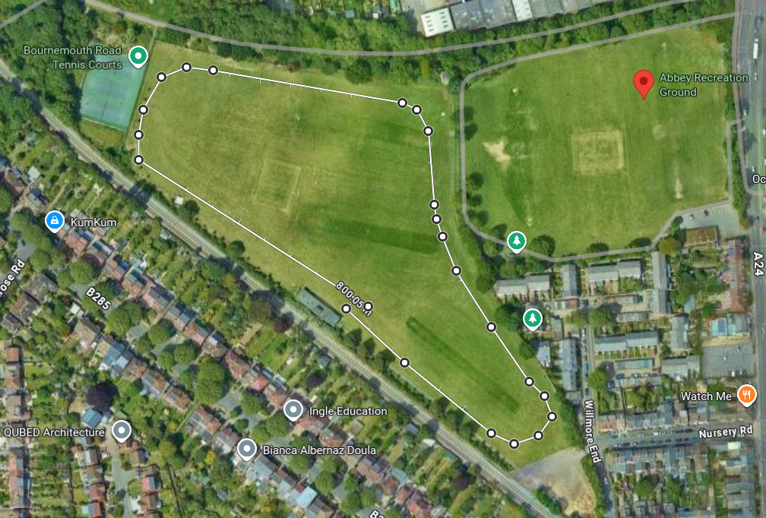

First Aid
MSSP will have a basic first aid kit and qualified person at all events but will not be available to tend to less urgent first aid, as they will be delivering the event. As part of the school’s risk assessment a qualified first aider should always be with the school team (including travel) to tend to their children during the event.

Team-sheets
To help us support our Equality, Diversity and Inclusion aims, all school teams must complete and submit the attached MSSP Event Entry - EDI Team sheet to register for this event. We do not require the children's names, just initials or first names are fine. This data is vital to help us improve equity and access for all. We want all Merton students to be able to represent their schools in activities they enjoy and, in an environment, where they feel a sense of belonging. The data you provide us will help us to review and improve our offer as we strive to achieve this.

Risk Assessments
Please see the Risk Assessment in the 'Resources' section on the event webpage for event specific planning and considerations.
mertonssp.org.uk/competitions

REFSPECT
MSSP values the contributions by all those involved in making our events a FUN, safe and enjoyable environment for children to take part in sport. To ensure our events continue to be successful we promote our REFSPECT campaign. We expect everyone attending our events to maintain respect for the rules, officials, opponents, teammates and themselves. Only designated staff and volunteers will be allowed on the side-lines. All spectators are to remain behind the barriers, providing positive support and encouraging a fun and fair event.
If any staff, adults or children are deemed to be in breach of our REFSPECT codes of conduct they will be asked to leave the event, and the Head Teacher of the relevant school will be informed immediately.

For more information about REFSPECT and codes of conduct for attendance at our events, please click here
mertonssp.org.uk/refspect

Photo Consent
Photographs will be taken at this event by staff members from MSSP and may be used for promotional material. If you have any children that do not have permission to be photographed, please inform a member of staff before the start of the event.
Please ensure your school only take photographs of their own students and do not share any photos of other children on social media without consent from that school.

Social Media
For information and updates from our events, please follow and use the platforms below:

Email: info@mertonssp.org.uk

X: x.com/MertonSSP

Instagram: instagram.com/mertonssp

MSSP Duty of Care
MSSP have a duty to take all measures that are reasonable in the circumstances to ensure the health, safety, wellbeing and welfare of all participants and any other attendees involved in the relevant event. MSSP have tried to ensure that all reasonable steps have been taken in its duty of care being discharged, and to the requisite standard of care, MSSP have ensured the following guidance and actions have been adhered to and carried out:
That the advice of the UK Government and public health authorities has been followed
That the bespoke guidance and protocols issued by the relevant NGB, federation and/or umbrella organisation (if applicable) have been followed.

Safeguarding and DBS
MSSP acknowledges the duty of care to safeguard and promote the welfare of children and is committed to ensuring safeguarding practice reflects statutory responsibilities, government guidance and complies with best practice and the requirements of the Partnership’s host organisation, the Harris Federation.

We recognise that the welfare and interests of children are paramount in all circumstances. We aim to ensure that regardless of age, ability or disability, gender reassignment, race, religion or belief, sex or sexual orientation, socio-economic background, all children and young leaders:
have a positive and enjoyable experience of sport or physical activity at MSSP events in a safe and child centred environment are protected from abuse whilst participating or officiating at MSSP events.

All MSSP staff at the event are fully vetted and enhanced DBS checked. It is the schools’ responsibility to ensure any staff and volunteers who attend the event comply with the host venue safeguarding and welfare policy and can provide documentation to support this on request.

If you have any concerns about a child at our event, please make sure you say something. The MSSP safeguarding team contact details will be on display at all events or for more information on who to speak to please click here
mertonssp.org.uk/contact

Comments, Compliments and Complaints
MSSP aims to deliver a first-class service to all its stakeholders. We see all feedback, whether good or bad, as a valuable way for us to learn and improve. Therefore, we welcome all comments, compliments and complaints. For further details, please click here
mertonssp.org.uk/comments-compliments-and-complaints

