
Risk Assessment Form 2025-26
Event or Activity | Gymnastics | Date/s | 04/02/26
Specific activities | Core Skills solo routines, Working Together pairs routines and sole vault attempts for U9 and U11 age categories in line with British Gymnastics RISE routines.
Other MSSP Activities at Canons 2025/26 | Basketball Development Yr 5/6 (12/11/25)  Inclusive Seated Volleyball/Kurling (26/11/25)  Sportshall Athletics (03/12/25)  Sportshall Athletics (10/12/25)  Inclusive Boccia KS2 (21/01/26)  Activate Multi Skills Festival Yr 5/6 (23/01/26)  Gymnastics (04/02/26)  Gymnastics (11/02/26)
Venue and areas used | Sportshall and toilet facilities at:  Canons Leisure Centre, Madeira Road, Mitcham, CR4 4HD
People in attendance | Primary school children, MSSP staff, visiting judges, school staff  – No spectators permitted at MSSP events.
Number of attendees | Approximately 80 children and school support staff, 6 MSSP members.
Venue assessed by | Nick Osborne | Date of Risk Assessment |  | January 2026

Images of facilities in use:
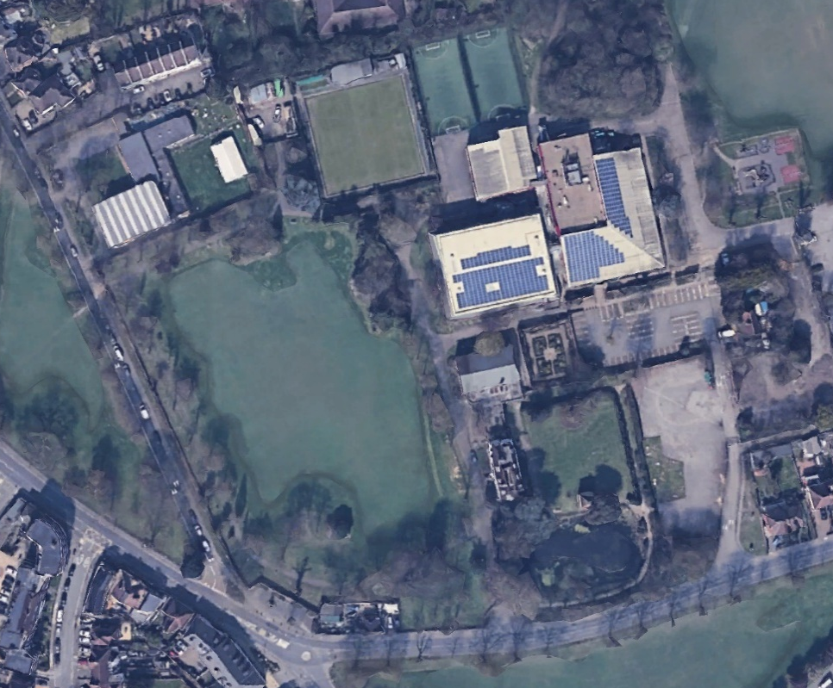
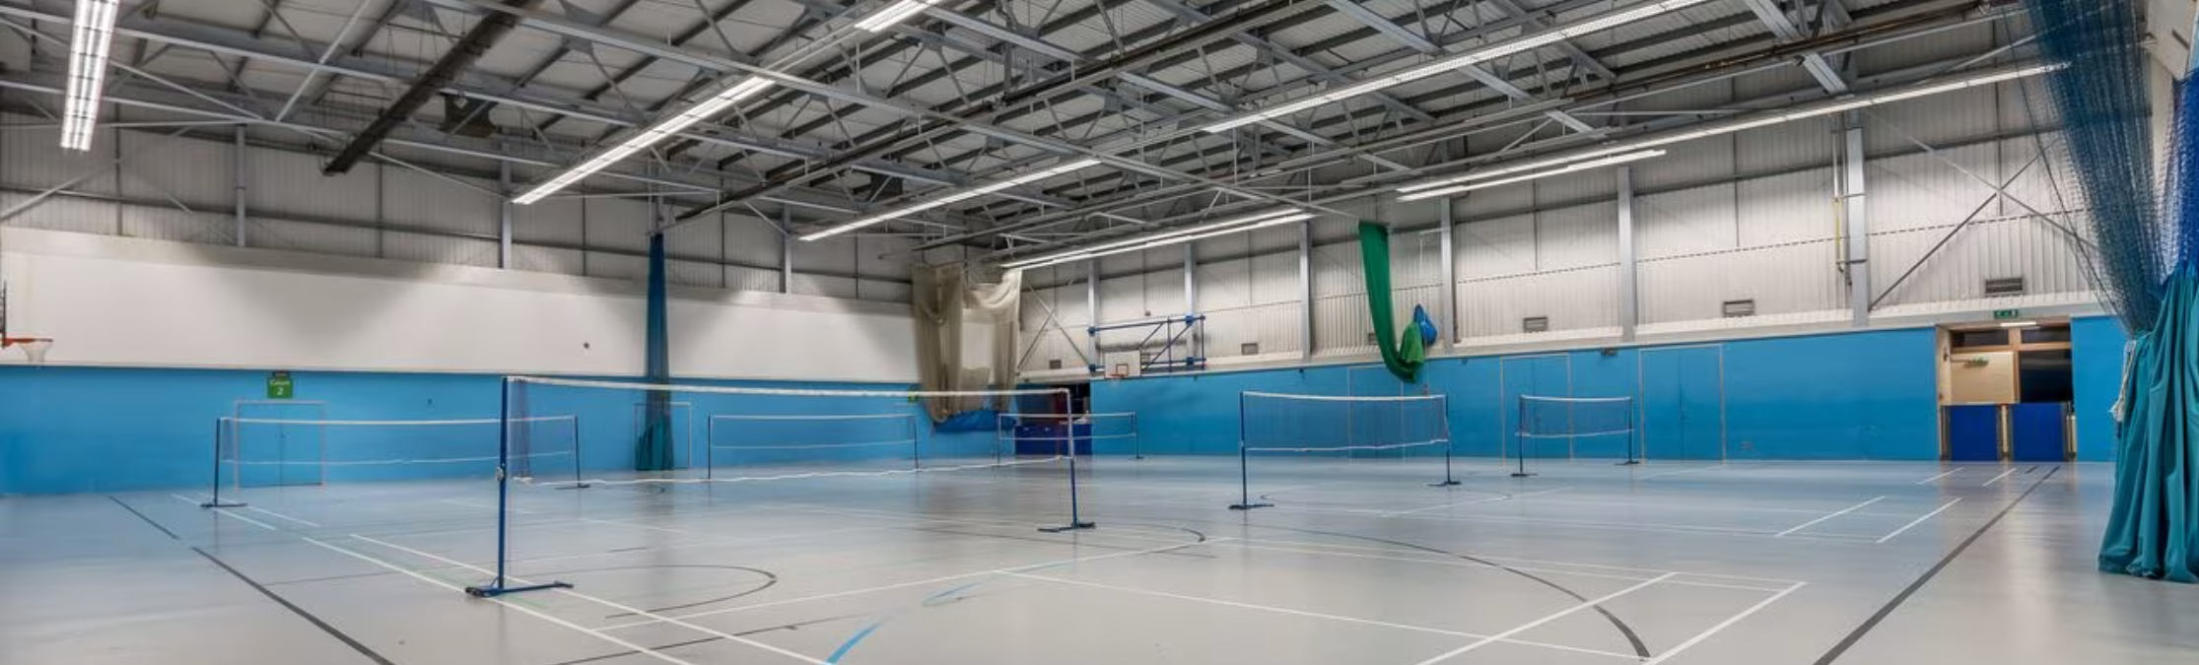
1 – Sportshall
2 – Event entrance
3 – Toilet facilities
4 – Evacuation meet point
5 – Car park
6 – Maderia Road entrance









Facility / Location Hazards | Risk L,M, H or X - None | Factors in place to reduce or avoid risk | Checked
Video tour of venue available via: |  | x
Inappropriate lighting | L | Indoor event. Sports-hall checked for sufficient lighting throughout timing of event.
Temperature | L | Indoor event. Sports-hall checked for regular temperature throughout timing of event.
Noise/Sounds/Atmosphere | M | Indoor arena can create loud acoustics when large numbers of people are participating. Ear defenders are advised to be used for children who may find these atmospheres of loud noises uncomfortable.
Insufficient or unsuitable space | L | Large sports hall used to accommodate sports and activities taking place. Space available around the sides of the playing areas for children to wait safely.
Untidiness – causing trips, injuries / fire hazard | L | Area used is checked before event takes place and visitors arrive.
Stairs – dark / steep / no handrail | M | Accessible ramp available for use of chairs and walkers to gain access to the playing space and toilets. These are on the ground level but with a few steps needed to access the playing space that is lowered slightly.
Lack of fire escapes / extinguishers / procedures | L | There are 4 ways to exit the sports hall if in need of quick evacuation. These will lead to different parts of the facility and this will be explained during the welcome briefing to all staff and children. GLL staff onsite at all times with access to extinguishers if needed in event of fire. The primary meeting point will be the grass field to the west of the sports hall as pictured in the map attached.
Slip / trip / fall hazards | L | Area checked for trip hazards before event takes place.
Working at height | L | No requirements for staff or children to be working at height.
Inadequate ventilation | L | Sports hall ventilated and suitable atmosphere for large numbers of participants. Doors accessible for further airflow.
Inhalation of dust or chemicals | L | Unlikely, not close to any industrial work. No planned works onsite due to take place.
Poor surfaces for activities – slips / trips / impact | L | Sports hall courts area checked by GLL and MSSP staff before event for safe use.
Electrical hazards | L | PA system extension cables to be taped down before use. MSSP staff only to use PA system.
Toilet Facilities | L | Toilets situated nearby the Sports hall and all children must be accompanied by their staff adult to the corridor. Toilets will be checked by MSSP staff and site staff ahead of the event.  Signs to indicate which toilets are to be used GIRLS, BOYS, ADULTS, ALL ACCESS.
Access to facilities including for disabled people | L | Event on ground level but with 3 steps down to the hall itself. Disabled changing and toilet facilities available and there is a ramp for access for those using chairs and walkers.
Weather extremes: Hot/Windy/Wet/Cold/Ice | L | Indoor event.
Thunder / Lightening – NB if Thunder is heard or lightening visible our policy is to:  Ask teachers to bring all children inside or suitable under shelter from any outdoor exposed areas. Do not wait under the shelter of trees.  MSSP will watch, listen and wait for at least 30 minutes from hearing the last the sound of thunder/lightening and consider the clouds above before children may resume play. The event may be cancelled if the storm clouds do not move on and the forecasts anticipates ongoing thunder rand lightening.  If storms are predicted - is there an indoor shelter to house the participants?  Have teachers considered how to get children home safely if thunder and lightning? | L | Indoor event
Animals access to facility – could harm people or foul the area | L | Indoor event
Other activities and spaces can be accessed on the event site | M | Venue is a private booking for the duration of the event. No members of the public or spectators are permitted to enter the sports hall whilst the event is taking place.  Branding used to isolate our area of use. MSSP and school staff to wear yellow sash to distinguish them from the public.

Sporting Activity Hazards | Risk L,M, H or X - None | Factors in place to reduce or avoid risk | Checked
Uneven playing surface or craters in surface | L | Hard-courts will be checked prior to activity commencing to ensure they are fit for use. Any areas deemed unsafe will not be used for the event.
Playing surface too hard or soft or wet | L | Hard-courts are checked prior to activity commencing for safety.
Hard or sharp objects on pitch/court | L | Hard-courts are checked prior to activity commencing for safety.
Sliding on Astroturf or tarmac | L | Indoor Hard-court event. No sliding permitted by participants.
Use of correct equipment for age, ability, type of activity | L | All equipment used will be age-appropriate and used in accordance to any NGB regulations per sport. Softer, lighter objects will be used where possible to reduce risk of injury or impact.  Gym vaults set at appropriate heights according to British Gymnastics standards for school sport competitions.  Merton Gym Club roll out mats used for Core Skills and Working Together Routines.  Safety landing mats and springboards inspected and in place for vault take off and landings.
Collisions / Conflict with surrounding objects or people | M | All children reminded in briefing before event of non-contact nature to these multi-skill sports and to avoid collisions with other players as much as possible.  Surrounding area divided with safety barrier and all bags, coats and belongings advised to be kept behind the barrier to keep them off the playing spaces.  Only 1 child permitted to attempt the vault run up at a time – school staff to assist the mounting and dismounting where necessary per their own children.  Vaults will not be accessible for general use. Practice time will be allocated accordingly.
Impact from sports equipment | M | All children given a safety briefing before event takes place. Children must remain behind a safety line for any throwing/pushing activities and must wait for children to return before taking their go, ensuring the space is safe and free to go.
Contact sport injury | L | All children given a safety briefing before event takes place. Non-contact sport rules applied where possible.
Personal injury – fracture / sprains / cuts | L | Emergency first aiders to attend with their own school team. MSSP supply back up first aid kit on site with equipment and clear access for emergency services if required.
Activity suitable for disabled participants | M | Schools are informed of the type and levels of activity so they can consider if the activity is suitable for their students. All multi-sport activities have be planned and designed with inclusion differentiation options.
Rules used as directed by NGB of sport | L | Rules used in events are NGB approved per sport and backed by London Youth Games formats.  RISE Gym routines followed and set per age category.
Age range and ability of children suitable to play against each other | L | Maximum age range upheld, schools to consider size and ability of any younger students should they want them to take. All multi skill activities are non-contact based.  Yr 3/4 gymnasts should no attempt activities set out for Yr 5/6.

People & Organisational Hazards | Risk L,M, H or X - None | Factors in place to reduce or avoid risk | Checked
Lack of information, training or instruction | L | All attendees are briefed thoroughly at the start of the event concerning items such as first aid, competition format, toilet access, safeguarding issues. This information is also available on the website when booking the event.
Poor activity planning or preparation | L | The needs of the participants and type of activities are considered when planning the event including competition format, toilet access, safeguarding issues, equipment and risk assessments. Public space booked in advance.
Poor activity delivery or organisation | L | Staff are trained and experienced to deliver the activity as planned and risk assessments continue throughout the event to manage and changes to safety.
Ignorance of rules and / or procedures | L | Rules are available and given out to PE Co’s before event to go through with children competing as well as parents/coaches. Rules and procedures are also recapped on the day during the briefing.
Unsafe behaviours or attitudes | M | REFSPECT campaign is in force for all competitions and all attendees are clearly reminded about what is expected of them during the event and the sanctions they face if they are not followed. School staff are accountable for their own staff and students behaviours and that of any spectators linked to their school. Leaders are monitored at all times and well briefed.  NO PARENTS/SPECTATORS ARE PERMITTED TO ATTEND THIS EVENT
Lack of appropriate first aid equipment and experience | M | First Aid kits are checked and re-stocked before each event however schools are reminded that they are responsible for the first aid of their students and staff although MSSP will support this where necessary in cases of high concern
Medical conditions of participants | M | School staff should consider the medical needs of children the bring to events and ensure they are capable of taking part safely and have any relevant medical items to hand throughout the event.
Poor safety control from group leaders | L | Group leaders and MSSP staff are all safeguarding trained. MSSP will oversee the event and deal with any concerning safety control within the event.
Poor safety awareness from participants | L | Children are given a brief safety awareness talk from MSSP but school staff should provide a full briefing before they make their way to the event.
Lack of cooperation within group | L | Visiting staff briefed on responsibility towards own team and REFSPECT campaign branding in view throughout event. Any concerning behaviour will be reported to the school’s Head Teacher.
Differing skill levels within group | L | Schools are briefed prior to the event on the nature/standard of the competition and are given advice on the appropriate ability level of children they should select. MSSP will intervene in any fixture or game where differing levels could impact the safety of participants or if the emotional wellbeing of participants is likely to be seriously impacted.
Low level of physical fitness / strength | L | Schools are briefed prior to the event on the nature/standard of the competition and are given advice on the appropriate ability level of children they should select. MSSP will intervene if it is evident that a child could become injured from a lack of physical ability during any task or activity.

People & Organisational Hazards | Risk L,M, H or X - None | Factors in place to reduce or avoid risk | Checked
Aggression between participants | L | REFSPECT campaign is in force for all competitions and all attendees are clearly reminded about what is expected of them during the event and the sanctions they face if they are not followed. Referees are also briefed to notify MSSP staff of any inappropriate behaviour from a player. School’s will be asked to manage any aggressive behaviour from their own party.
Aggression from crowd / public | M | REFSPECT campaign is in force for all competitions and all attendees are clearly reminded about what is expected of them during the event and the sanctions they face if they are not followed. Inappropriate behaviour will also be recorded and reported back to the associated head teacher to follow up. If any attending adult displays concerning behaviour MSSP will contact the police but schools should protect their own children based on their educational visits policy and procedures.  NO PARENTS/SPECTATORS ARE PERMITTED TO ATTEND THIS EVENT. ONLY REGISTERED PARENT HELPERS THAT ARRIVE WITH THE SCHOOLS WILL BE PERMITTED. IF PAENTS/SPECTATORS ARRIVE AT EVENT AND REFUSE TO LEAVE, ALL ACTIVITY/MATCHES WILL BE HALTED WHILE THEY ARE ONSITE AND THE SCHOOL WILL BE CALLED.
Contact between participants increasing risk | L | All children given safety briefing prior to event to reiterate non-contact and safe behaviours towards others.
Participants with special needs | L | Schools are briefed prior to the event on the nature/standard of the competition and are given advice on the appropriate ability level of children they should select. Event is adapted according to skill levels of children.
Participants warmed up appropriately | L | It is the school’s/parents responsibility to ensure the children are dressed appropriately. Event information including location, surface played on are sent to schools in the weeks leading up to the event. School teachers are to lead their teams in warm ups.
Terrorism/Emergency evacuation | M | To the outside area – In the case of a sudden need to move all children from the venue, MSSP will work with teachers to identify the safest exit to use and ask children to return to the school teacher in their school waiting area which will be marked out in the competition area at the start of the event. Schools to decide and to communicate with their children where/how to evacuate and which exit to use based on the situation and response to an unexpected danger.
Participants wearing safety clothing or accessories – i.e shin pads, mouth guards | L | It is the school’s/parents responsibility to ensure the children are equipped appropriately. Event information including location, surface played on are sent to schools in the weeks leading up to the event. Children may get muddy if the weather is/has been wet.
Participants wearing suitable attire | M | It is the school’s/parents responsibility to ensure the children are dressed appropriately. Event information including location, surface played on are sent to schools in the weeks leading up to the event.
Danger of interference by members of the public | M | MSSP Staff and Visiting teachers briefed and stationed around the start/finish areas between spectators/members of the public. Schools should brief children on ‘stranger danger’ before attending the event.  NO PARENTS/SPECTATORS ARE PERMITTED TO ATTEND THIS EVENT. ONLY REGISTERED PARENT HELPERS THAT ARRIVE WITH THE SCHOOLS WILL BE PERMITTED. IF PAENTS/SPECTATORS ARRIVE AT EVENT AND REFUSE TO LEAVE, ALL ACTIVITY/MATCHES WILL BE HALTED WHILE THEY ARE ONSITE AND THE SCHOOL WILL BE CALLED.
Photo consent for children / staff / volunteers / officials | M | All consent is recorded at the start of the event when they sign in.  SOME CHILDREN WILL HAVE STRICT NO PHOTO CONSENT. SCHOOL STAFF MUST NOT TAKE ANY GENERAL PHOTOS WITH CHILDREN FROM OTHER SCHOOLS IN. STAFF TO BE VIGILANT IN MANAGING THIS. MSSP WILL TAKE PHOTOS ACCORDING TO WHO IS PERMITTED VIA THE REGISTER.
Pregnancy or Conditions to consider safety of Staff / Volunteers | L | Suitable chairs and benches available for visiting staff and volunteers. These are set back away from the playing spaces.

Sports Leaders | Risk L,M, H or X - None | Factors in place to reduce or avoid risk | Checked
Leaders briefed and trained to support at event | L | If required, leaders will be offered officiating training prior to the event taking place. Leaders will be supported on the day with a member of MSSP core staff observing each playing pitch/court.  Adult judges from local gym clubs will be used for this event. All judges will be always supervised and briefed on our MSSP Code of Conduct and expectations at events.
Supervision of leaders / volunteers/ officials | M | Sports leaders to be supervised by a member of their own school staff/PE department for the duration of the event, as well as MSSP staff (all have enhanced DBS’s and are HAMD CP trained)
Transportation of leaders to and from event | M | Sports leaders will make their own way to the venue.
Photo consent for leaders | L | All consent is recorded at the start of the event when they sign in.
Post event plan for leaders – to be dismissed from the venue, collected by parents, escorted back to school, in the care of staff or teacher? | M | The member of school staff accompanying the sports leaders will make the decision on the day to either dismiss them from the venue or take them back to school site.

Equipment and Other Hazards | Risk L,M, H or X - None | Factors in place to reduce or avoid risk | Checked
Cash handling | X | Not applicable
Transport to and from your activity | L | All MSSP staff will make their own way, It is the school’s responsibility to arrange appropriate transport for their team of children.
Transport of equipment to and from the activity | L | MSSP equipment transported by MSSP staff in insured vehicles.
Hazardous substances | L | Anti-bacterial wipes, gel and spray will be used and the COSHH advice followed accordingly. School staff to observe chn throughout to ensure they do not mis use hand cleaning products or have access to cleaning products.
Hot Liquids | L | No hot liquids should be brought in to playing space. Hot drinks, if any, should be consumed outside or in the corridor/café area.
Heavy equipment and lifting | M | Staff work as a team when lifting heavy equipment and do this appropriately.
Electrical hazards from equipment | M | All equipment is safety checked.
Noise from equipment | M | PA system is tested and volume not put too high.
Risk of trapping body / clothing in equipment | M | Staff work as a team when lifting/moving heavy equipment and do this appropriately.

Inadequate environment for equipment operation

Inadequate protective equipment
Equipment in unsuitable condition | L | Equipment is safety checked and replaced if unfit for use.
No access to phone | L | MSSP office mobile available in emergencies.

Safeguarding | Risk L,M, H or X - None | Factors in place to reduce or avoid risk | Checked
All MSSP staff, self-employed coaches, volunteers DBS cleared and safeguarding protocols met. Schools following own protocols. | M | DBS information, if required, is sent to venue prior to event taking place as well as all members signing in on arrival.  Adult judges from local gym clubs will be used for this event. All judges will be always supervised and briefed on our MSSP Code of Conduct and expectations at events.
Correct ratio of staff to children | M | Schools are in charge to ensure they have the correct staff for the number of participants they are bringing.
Public place – strangers / animals | M | Site will be checked prior to the event and again upon staff/children arrival. Barriers set out to notify any gym members or members of the public of a segregated event.
Adequate 1st aid treatment | M | MSSP staff are emergency first aid trained and schools have been asked to bring their own first aider and equipment with them to each event.
Opportunities for one-on-one contact with children | L | MSSP staff/leaders are not put in 1-1 situation as there is always a second person with them with a child. All briefed to always stay with their school group.  Adult judges from local gym clubs will be used for this event. All judges will be supervised at all times and briefed on our MSSP Code of Conduct and expectations at events.
Transportation of staff / children | L | Schools responsible for transport to and from the event.
Phones use of by staff, leaders, volunteers, schools and public - media consent | M | Staff and Leaders have been asked to put their phones away during a competition and only used in emergency situations. If a picture is taken on an MSSP device this is downloaded onto the MSSP server and used for promotional purposes, it’s then deleted from the device.

Swimming - lack of clothing considered for photography
Behaviour of adults and children towards children and young leaders | M | REFSPECT campaign is in force for all competitions, and all attendees are clearly reminded about what is expected of them during the event and the sanctions they face if they are not followed. Inappropriate behaviour will also be recorded and reported back to the associated head teacher to follow up.  NO PARENTS/SPECTATORS ARE PERMITTED TO ATTEND THIS EVENT
Sign in / Out - Registration | L | Always completed by a sign in form on arrival for all attendees notifying phot consent.
Other activities taking part or other children on the event site | M | No other activities taking place in the sports hall during time of event. General use of Canons Swimming and Gym are still accessible to members of the centre.

Record of Incidents and Accidents at Event or Activity
Please complete this section during/after the event. To include: Date, time, description (factual), people involved, treatment or actions taken, follow up and future recommendations:

Date | Time | Incident description | People involved – (school and child first name only) | Treatment/Actions taken
Completed by: Role:

Date | Time | Incident description | People involved – (school and child first name only) | Treatment/Actions taken
Completed by: Role:

Date | Time | Incident description | People involved – (school and child first name only) | Treatment/Actions taken
Completed by: Role:

